
Academic Archive
www.gallipoli-music.co.uk/academic-archive.htm
Selahattin Adil Pasha
January 1882-27 February 1961

Biography | 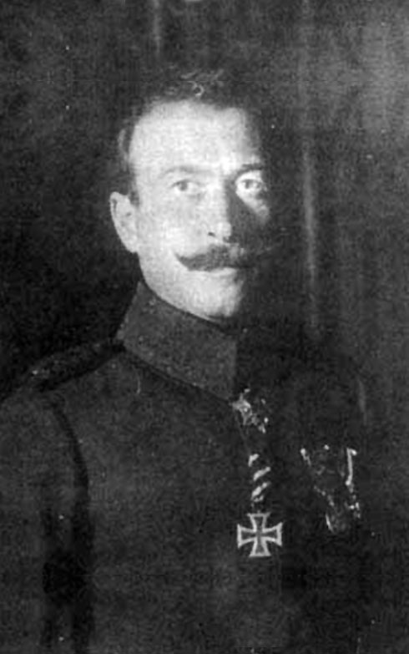  He was born in January 1882, the son of Adil Pasha (1847-1905),  who was also a General in the Ottoman army. He graduated from the Staff College in 1902 as a Captain, and was posted first to the 5th Army (Damascus) and then the 3rd Army (Salonika). In 1906 he was appointed an assistant instructor in the Military College (Mekteb-I Harbiye). At the time of the ‘31st of March Incident’ of 1909 (an attempt by conservative elements in the army, probably instigated by Sultan Abdul Hamid, to overthrow the regime established by the Young Turk revolution of 1908) he served in the ‘Action Army’ which advanced from Salonika to Istanbul to restore the Young Turk government. He was appointed Military Attaché in Bucharest before serving in the war against the Italians in Libya (1912) and then in the Balkan Wars (1912-13).  At the time of the Anglo-French naval attack on the Dardanelles (18 March 1915) he was a Lieutenant-Colonel and commander of the fortified lines and artillery in the Straits. As such, he helped to secure the defeat of the entente navies, having had telephone lines connecting him to all the fortifications and guns controlling the narrows. Following the allied landings in the peninsula, he was appointed commander of the 12th Division by Mustafa Kemal [Atatürk], the Commnander of the Anafartalar Group, and commanded the Turkish forces in the third battle of Krythia. Until June he served on the left flank of the southern (Seddülbahir) front, where his forces repulsed attacks by the British and French at Kerevizdere. However, the division suffered serious losses of killed and wounded in these battles, and was withdrawn to Gallipoli to recover. After a month the division was sent back to join the Anafartalar Group comnand, to counter the allied landings of 6 August on the Anafartalar beaches. On 9 August the division defeated the numerically superior allied forces in the first battle of Anafartalar. In September Selahattin Adil was re-appointed to command the 13th division, again on the Seddülbahir southern front.  For most of the rest of the war he served on the eastern front, until the final months when he was re-appointed commander of the fortified lines and artillery in the Dardanelles. It was thus very ironical that, after the Armistice of Mudros he had to hand over the straits fortifications, which he had successfully defended just three years earlier, to the allied occupation forces.  During 1920 he was in Istanbul, and organised meetings with the young officers in the Staff College to encourage them to join the nationalist forces being organised in Anatolia to resist the entente. In June 1920 he himself went to Anatolia to join the resistance army. He was initially appointed to command the Adana front, to build up the nationalist forces in the region, which was under French occupation, and to prevent expansion of the occupied area. In 1921 he joined the western front and participated in the battle of Sakarya as commander of the 2nd Army Corps. His success in this battle earned him promotion to Brigadier-General and the title of ‘Pasha’. Subsequently he was appointed an under-secretary (Müsteşar) in the Ministry of Defence.  He became a Deputy in the first Grand National Assembly (1920-23) while serving in the high command during the offensive of 1922. After the Armistice of Mudanya military control in Istanbul was passed in stages to the 81st Regiment, which he commanded. As a result, he was appointed Istanbul Commander by the Grand National Assembly. On 23 September he resigned from the army, and served in a number of government positions from then until 1950, when he became a Deputy for Ankara from the Democrat Party, which won the elections in that year. He left the Assembly in 1954.  During the post-war period he became a successful industrialist.  He died in Istanbul in 1961.
The community | Kurdish
Correspondence | In 2007 his letters and memoirs from the Dardanelles campaign were published (Selahaddin Adil Pasa’nın Çanakkale Cephesinden Mektuplar-Hatıralar).  Selahattin Adil (ed. Enver Koray), Hayat Mücadeleleri- Selahattin Adil Paşa'nın Hatıraları, Zafer Matbaası, 1982 (BLL01010612569: 519pp 20 plates)
Other primary sources | Adil,Selahattin (1982) Çanakkale Hatıraları in Çanakkale Hatıraları, 1 Clt. Istanbul:Arma
Where commemorated | Devlet Mezarlığı Ankara : State Cemetery
Gallantry awards | Iron Cross (Turkish);The Osmanie Order; Imtiaz medal; Turkish War medal 1915
Secondary sources | Erickson Edward J. (2010) Gallipoli: The Ottoman campaign Pen & Sword Military  T.C. Genelkurmay Harp Tarihi Başkanlığı Yayınları, Türk İstiklâl Harbine Katılan Tümen ve Daha Üst Kademlerdeki Komutanların Biyografileri, Genkurmay Başkanlığı Basımevi, Ankara, 1972, p. 117. (Turkish)  http://harunaron.blogspot.co.uk Arun Harun is a descendant of Selahattin Adil Pasha. The site contains some excellent photographs.



